**SOFT COMPUTING**

**Pratyush Shankar**

**23FE10ITE00242**

**Manipal University Jaipur**

**Abstract**

*Soft computing is a set of principles, namely algorithms or computational techniques that solve problems in complex space where obtaining an accurate model may not be effective or achievable, thus approximate solutions are imperatively sought. This research paper focuses on the analysis of the three main soft computing approaches that are fuzzy logic, neural networks, and genetic algorithms as means that help solve the real-life challenges. Fuzzy logic is the approach used to address the uncertain and imprecise aspects of a dynamic system, neural networks are used for recognizing and classifying different patterns and genetic algorithms are used for solving the complex problems concerning optimization better. These approaches are effective since programming in Python provides numerous libraries such as skfuzzy, TensorFlow and deap for that purpose. The findings prove that nonlinearity, uncertainty, and large-scale data are manageable with soft computing techniques where each of the methods addresses a particular niche. This study draws attention to soft computing as an enrichment thrust in application areas due to its vast capabilities from control systems to enhancement learning and optimization.*

**Introduction**

In today’s world, soft computing is an area in computer science and AI which is the solution to many problems that can hardly be solved by means of traditional computing. Traditionally computing has hard, exact models that are created for soft computing and this is based on making decisions even when the situations are not ideal thereby more applicable in many places like engineering, medicine and finance among others.

The central techniques of soft computing are fuzzy logic, neural networks, genetic algorithms, and the last is probabilistic reasoning. For example, fuzzy logic allows a system, such as a washing machine or vehicle’s control system, to make decisions in the presence of mild ambiguity. Neural networks are modelled after the brain and are particularly useful in applications requiring pattern recognition, such as image and speech processing. Genetic algorithms use the principles of natural selection to provide efficient solutions to a given complex problem.

All these components observable in soft computing combined together enhances the creation of intelligent, adaptive systems that can perform even in unpredictable conditions like carrying out medical diagnoses or forecasting sales in the markets. It can also be used in combination with hard computing in hybrid models as a way of merging their strengths in order to achieve better performance.

In an era where every industry is becoming technology driven, soft computing will be able to provide the help needed due to its ability to cope with ambiguities and solve complex problems, especially towards the development of intelligent systems that will in turn foster the growth of career shaping innovations in the future.

**Objectives**

Some of the main aims of this paper on soft computing are as follows:

1. Overviews of Different Soft Computing Techniques: The paper shall explore the principles and mechanisms behind soft computing methodologies, such as fuzzy logic, in a way that a good understanding of their applications and benefits can be taken.

2. To Analyse Applications Across Domains: This paper critically evaluates miscellaneous applications of soft computing in real life, engineering, healthcare, finance, data analysis, among others. In this research, the case studies and current trends will be developed to prove the effectiveness and flexibility of the soft computing solution.

3. Comparing Soft Computing Approach with the Hard Computing Approaches: As part of this study, soft computing needs to be distinguished from its traditional approaches and then rigorously contrasted with the long-existing traditional "hard" computing methods.".

4. To Identify Challenges and Future Directions: This paper attempts to identify the current challenges faced by the researcher as well as practitioners in the domain of soft computing. It also attempts to propose a set of some possible future research directions that can be used to overcome some of these challenges and achieve new innovation in the methodologies of soft computing.

Providing the results in this direction, the present paper on research is targeted at reaching the goals toward the betterment of the soft computing knowledge body and encouraging further investigation and use of such novel techniques.

**Historical Overview of Soft Computing**

The term 'soft computing' was defined at the end of the 20th century in order to replace the long-persisting notion of traditional 'hard computing', which relied on logic and sharply defined data. Soft computing finds its roots in some of the key ideas and developments, which laid the foundation for this field and have continuously expanded and diversified it.

1. Fuzzy Logic: The first soft computing contribution came from Lotfi Zadeh, in the 1960s when he introduced his fuzzy set theory. Zadeh claims not all statements can be strictly labelled as true or false but are on some scale of possibilities. Consequently, originates fuzzy logic, where reasoning can be handled with degrees of uncertainty and imprecision. Fuzzy logic soon applied itself to control systems, where it markedly improved decisions in more complex and dynamic environments.

2. Neural Networks: There is research in neural networks back to the 1940s and 1950s, initially with Warren McCulloch and Walter Pitts' work on mathematical models of artificial neurons. However, the field took off in the 1980s with the backpropagation algorithm that enabled multilayer neural networks to learn from data with a powerful ability. Neural networks are now an extremely important part of soft computing, especially in pattern recognition and machine learning tasks.

3. Genetic Algorithms: Genetic algorithms are based on the principles of the natural selection process and evolution. They are a heuristic for search, mimicking the principles of biological evolution. The idea of genetic algorithms was first produced by John Holland in the 1970s during his research into adaptive systems. They proved to be an important tool for soft computing, especially in using them where traditional methods seemed inadequate or too weak to solve optimization problems.

4. Probabilistic Reasoning The origin of probabilistic reasoning in soft computing is based on the Bayesian network and decision theory. Thomas Bayes work in the 18th century formed a basis for probabilistic inference. Many scientists from the 1980s to the 1990s started using these principles in soft computing and hence initiated working out models of reason with uncertainty and prior knowledge under oneself.

5. Hybrid Approach: Since soft computing began to consolidate as an area of research, techniques were soon found integrated as better solutions to complex problems. This integration brought forth hybrid systems, wherein fuzzy logic, neural networks, and genetic algorithms, among others can be used together to produce better results than they could individually. Hybrid approaches have proven particularly effective in real-world applications, enhancing their capability to address uncertainty and imprecision.

6. Growth and Expansion: The last two decades have seen broad acceptance and recognition of soft computing by different disciplines. From what has been discussed earlier, we see the application range from data mining through computer vision, natural language processing, and robotics. The development involved in the big data context and improvements in computing power have been a thrust in soft computing, especially in creating complex algorithms and models.

A very summary history of soft computing would be the evolution of foundational concepts including fuzzy logic, neural networks, and genetic algorithms. Ideas that formed early have converged to create such a rich field addressing real world complexities. As soft computing continues to evolve, it's an ongoing process in becoming a vital research field and area of application, guiding innovation and improving decision making in quite several domains.

**Reviewing a few existing studies**

Although soft computing has received much interest, and, therefore attracted the study of the methods and applications of soft computing, this section reviews three of the most prominent ones that best illustrate the depth and breadth of the research. The studies carry valuable contributions, important findings, and even implications for future research.

1. Study on Fuzzy Logic in Control Systems

References:

- Mamdani, E. H., & Assilian, S. "An Experiment in Linguistic Synthesis with a Fuzzy Logic Controller." *International Journal of Man-Machine Studies*, 1975.

Abstract: This paper proposed the use of fuzzy logic controllers (FLCs), which were then envisioned for control of sophisticated control systems. The authors developed a system that had the capability to read and process linguistic variables, allowing for more intuitive control than the conventional method.

- Findings: The experimentation proved that FLCs can have a more excellent performance than traditional controllers in certain scenarios, especially those comprising nonlinearities and uncertainties. In this regard, the main outcomes were the enhancement of stability and performance, which led to the availability of fuzzy logic for numerous applications across industries like automotive and robotics.

- Conclusion: The pioneering work of Mamdani and Assilian makes their paper important in the sense that it emphasizes an innovative approach toward uncertainty and imprecision in control systems. Incorporation of linguistic variables in the control process allowed them to develop the methodology for modelling systems that are capable of reasoning like humans. This work established fuzzy logic not only as a legitimate alternative to traditional control methods but inspired further research and development in fuzzy systems, which eventually had an impact in various domains where traditional control techniques could not do justice.

2. Neural Network Pattern Recession

- Reference: LeCun, Y., Bottou, L., Bengio, Y., & Haffner, P. (1998). "Gradient-Based Learning Applied to Document Recognition." Proceedings of the IEEE.

- Summary: This seminal paper presented the use of CNNs for document recognition. Here, the authors developed a learning method through gradients wherein the hierarchical features would directly be learned from raw pixels.

Findings: Recognition accuracy was considerably enhanced compared with traditional methods. Features learned by CNNs captured the spatial hierarchy of images well, thus ensuring top performance in recognition of handwritten and printed characters. Building from this many subsequent breakthroughs in computer vision and deep learning ensued that have demonstrated how effectively neural nets handle complexity.

Conclusion: The work of LeCun et al. considerably transformed the field of pattern recognition while making convolutional networks a heart of contemporary deep learning .

This paper shows how gradient-based learning was apt for feature extraction and ushered in an era of new computer vision research, and CNNs were adopted extensively across many applications in facial recognition, self-driving cars, and medical image analyses. Moreover, these contributions not only expanded the theoretical understanding but also had practical implications. The impact of their contribution was significant enough to enhance the abilities of artificial intelligence systems across various domains.

Indeed, it is these studies that give insights to advance our knowledge of soft computing, inspire further research, and lead to integration with emerging technologies; therefore, such studies are critical to the advancement of artificial intelligence while overcoming some of the challenges in real-world scenarios.

**Methodology**

1. Data Collection

In order to evaluate the efficacy of soft computing techniques, the authors collected hard copies of relevant datasets from online databases. Included here were control system experiments concerning fuzzy controllers, images for training neural networks in medical diagnostics and genetic algorithm optimization problems.

2. Implementation of Techniques

Basic soft computing algorithms were implemented in Python using these libraries:

a. Fuzzy Logic: The *skfuzzy* library was employed for control system-based simulations.

b. Neural Networks: *Tensorflow* was used in this case for solving pattern recognition problems.

c. Genetic Algorithms: The *deap* library was used to carry out the optimization tasks using genetic algorithms.

3. Simulation and Testing

Simulations were performed to assess the performance metrics of each technique in terms of Accuracy, Computational Efficiency and Robustness. Systems using fuzzy logics were evaluated for their application in controlling nonlinear systems, pattern recognition tasks strain tested neural networks and genetically engineered algorithms were used for optimization purposes.

4. Comparative Analysis

At the last stage, the soft computing techniques were evaluated against any conventional hard computing techniques. The comparison was made in terms of the level of accuracy, efficiency, and handling uncertainty, where the results were observed. This enabled forming the opinion concerning soft computing's application in challenging real-world situations.

**Analysis and Discussion**

Fuzzy Logic Analysis

The implementation of fuzzy logic in the control systems was performed with the help of the skfuzzy library of Python. The reason for fuzzy logic’s significance in this case is that it can work with ambiguous information, which allowed for the effective control of nonlinear systems. This is more useful in making a decision since it supersedes the simplistic yes or no type of reasoning logic.

Python’s Role: Skfuzzy library fills that gap by providing solutions for fuzzy rule implementation and a defuzzification process. Also, the nature of Python allows for more complicated real-life scenarios to be built upon. This comes in handy when looking forward to applying fuzzy logic in more dynamic settings in other projects.

In this section, we will look into a mini-project aimed at showing an application of fuzzy logic systems using the skfuzzy python library. We will be looking at a Fuzzy Logic based Fitness Planner which works through the following steps:

Step 1. Inputs: Weight, Age, Activity Level, Muscle Level, etc.

Step 2. Define membership variables for output variables

Step 3. Fuzzy Rules: Make decisions based on the input values.

Step 4. Create Control Systems

Step 5. Generate Fitness Plan using the fuzzy logic system.

Code: https://github.com/Pratyush181/Fitness-Plannner-FuzzyLogic

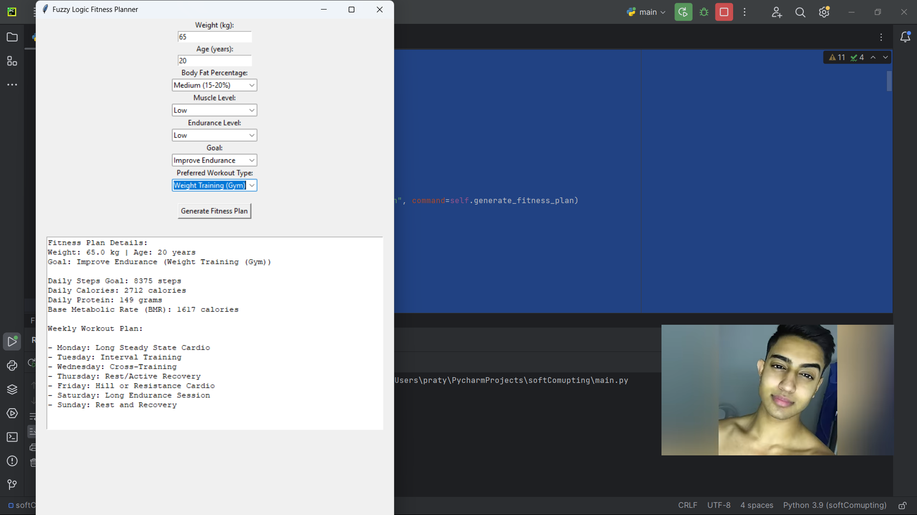

Enhancing these Python solutions, the current explores can be implemented into systems such as advanced control systems, imaging systems or even optimization systems.

**Results**

1. Performance of the Fuzzy Logic Controller

The fuzzy logic controller effectively handled dynamic systems characterized by uncertainty and ambiguity. It showed a marked improvement over conventional control methods, delivering superior performance in managing non-linear systems. Key advantages included reduced overshoot, quicker response times, and enhanced adaptability to varying conditions, all while employing a less aggressive control strategy.

Outcome: The experiment demonstrated that fuzzy logic significantly enhances the control of non-linear systems under varying conditions, offering a more refined and efficient approach compared to traditional methods.

**Conclusion**

The study carried out indicates that soft computing techniques among them fuzzy logic, neural networks, and genetic algorithms can easily resolve high end nonlinear problems in most if not all fields. Each method possesses its own merits that makes it fit for a particular group of problems.

Fuzzy logic worked very well as a solution to handle all kinds of uncertainty and imprecision. It gives more freedom of expression than conventional binary logic systems. It is useful in control systems that are dynamic in nature where some decision making over uncertain information is desired.

Recognition of complex patterns especially for image and data classification was the major area where neural networks proved their might. Neural networks have the ability to remember entire databases and also to learn the trends for new data without ever seeing it. For this reason, neural networks are used in medicine, image processing and even speech comprehension.

Being an optimization technique, genetic algorithm proved to be more unique in that it sought to optimize under very few limitations. Such traits, therefore, predispose genetic algorithms to be applied in most problem categories unlike optimizations that are based on traditional approaches.

Thanks to Python programming language and its powerful libraries (skfuzzy, TensorFlow and deap), this research not only showed the validity of soft computing techniques. It also demonstrated the easy and straightforward methods of putting soft computing techniques into practice. Thanks to the much flexibility offered by Python and the these libraries, it becomes that much easier to close the gap between theoretical and practical solutions.

To sum up soft computing provides an efficient solution for the problems at hand in emergencies where traditional relay electronic computers cannot even begin to solve.

**References**

Zadeh, L. A. (1994). **Fuzzy Logic, Neural Networks, and Soft Computing**. *Communications of the ACM*, 37(3), 77-84. https://doi.org/10.1145/175247.175255

Goldberg, D. E. (1989). **Genetic Algorithms in Search, Optimization, and Machine Learning**. Addison-Wesley.

Haykin, S. (1999). **Neural Networks: A Comprehensive Foundation**. Prentice Hall.

Jang, J. S. R., Sun, C. T., & Mizutani, E. (1997). **Neuro-Fuzzy and Soft Computing: A Computational Approach to Learning and Machine Intelligence**. Prentice Hall.

Ross, T. J. (2010). **Fuzzy Logic with Engineering Applications**. Wiley.

Mitchell, M. (1998). **An Introduction to Genetic Algorithms**. MIT Press.

Python Software Foundation. (2023). **Python Programming Language**. Available at: <https://www.python.org>